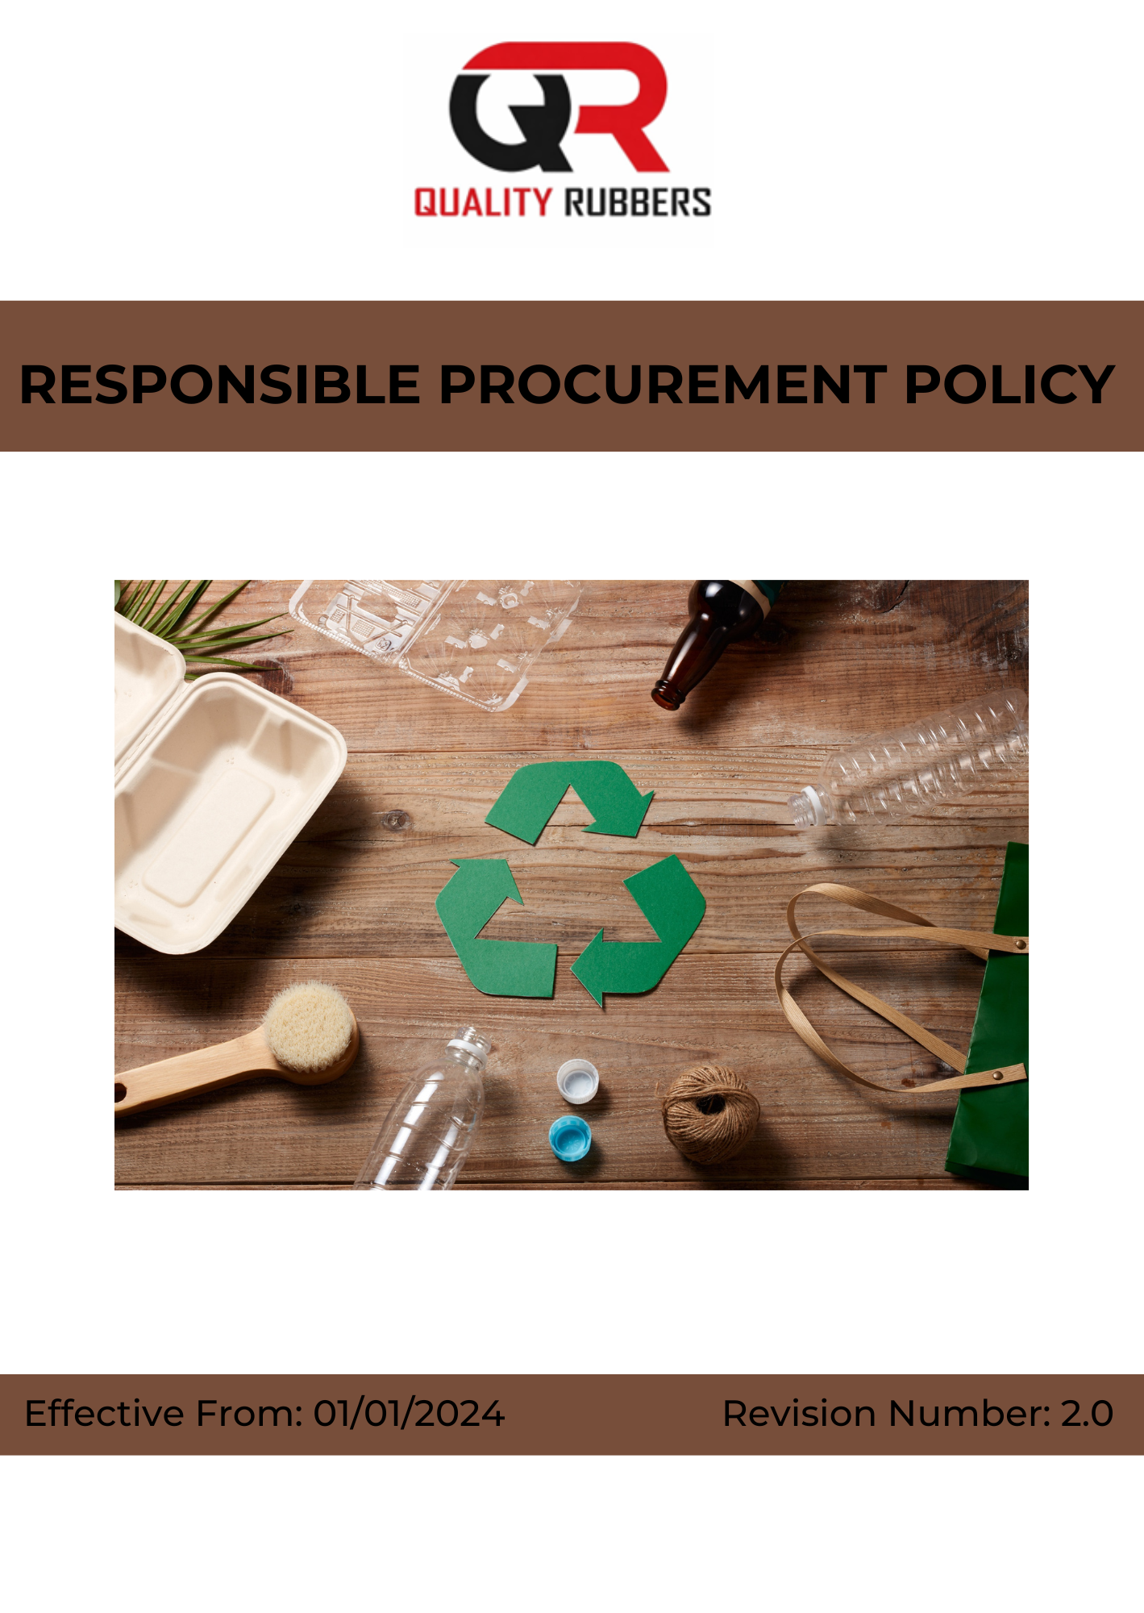

INDEX
1. Policy Intent 3
2. Scope of the Policy 3
3. Key Priorities for Responsible Procurement at Quality Rubbers 3
4. Quality Rubbers Responsible Procurement Commitments and Performance Areas 4
5. Organizational Responsibilities for Responsible Procurement at Quality Rubbers 7
6. Tracking and Monitoring Responsible Procurement Performance at Quality Rubbers 9
7. Performance Enhancement and Continuous Improvement at Quality Rubbers 9
8. Policy Review and Update Mechanism 10
9. Employee Acknowledgement 11

Policy Intent
Quality Rubbers is committed to conducting its procurement activities in a responsible, ethical, and sustainable manner. The Company recognizes that procurement decisions have a significant impact on environmental, social, and economic outcomes across the value chain and therefore seeks to integrate responsible sourcing practices into all procurement processes.

This policy establishes the intent to procure goods and services in a manner that promotes transparency, fairness, and accountability while ensuring alignment with applicable laws, regulations, and organizational standards. It reflects the Company’s commitment to working with suppliers and business partners who uphold ethical business conduct, respect human rights, maintain safe working conditions, and adopt environmentally responsible practices.

The policy aims to strengthen supplier selection, evaluation, and engagement processes by incorporating sustainability considerations, including environmental performance, labor practices, health and safety, and ethical governance. It also promotes traceability, risk assessment, and continuous improvement across the supply chain.

Through this policy, Quality Rubbers seeks to build long-term partnerships with responsible suppliers, minimize procurement-related risks, and contribute to sustainable development by ensuring that sourcing practices remain consistent, transparent, and aligned with global best practices.

Scope of the Policy
This policy applies to all employees, workers, directors, officers, contractors, and any third parties acting on behalf of Quality Rubbers. It also extends to all suppliers, vendors, service providers, and business partners engaged in procurement-related activities.

The policy covers all procurement and sourcing activities associated with the Company’s operations, including the sourcing of raw materials, processing-related inputs, storage, handling, transportation, and distribution. It further applies to all interactions with suppliers, contractors, regulatory authorities, and other relevant stakeholders involved in the procurement lifecycle.

Quality Rubbers | 10/587, Azhiyannur Post, Kadampazhipuram, Palakkad, Kerala, 678633, India.

Key Priorities for Responsible Procurement at Quality Rubbers
Quality Rubbers recognizes that procurement activities have a significant impact on environmental sustainability, social responsibility, and ethical business conduct across the supply chain. The Company is committed to integrating these considerations into supplier selection, evaluation, and engagement processes.

To support responsible sourcing, the following key priorities have been identified:

- We aim to promote responsible sourcing by engaging with suppliers who demonstrate environmentally sustainable practices, including efficient use of energy, water, and raw materials.
- We aim to encourage suppliers to reduce environmental impacts by minimizing emissions, waste generation, and pollution across their operations.
- We aim to support traceability and transparency in sourcing practices, including responsible procurement of raw materials and avoidance of environmentally sensitive or high-risk sources.
- We aim to promote compliance with applicable environmental laws, regulations, and standards across the supplier base.
- We aim to encourage suppliers to adopt fair labor practices, including prohibition of child labor, forced labor, and any form of exploitation.
- We aim to promote safe and healthy working conditions within the supply chain by encouraging suppliers to implement appropriate health and safety practices.
- We aim to support fair wages, reasonable working hours, and humane treatment of workers across supplier operations.
- We aim to encourage diversity, non-discrimination, and respect for human rights across all supplier workplaces.
- We aim to promote ethical business conduct by ensuring zero tolerance for bribery, corruption, and fraudulent practices within the supply chain.
- We aim to encourage transparency, accountability, and compliance with applicable legal and regulatory requirements among suppliers.

Quality Rubbers Responsible Procurement Commitments and Performance Areas

1. Supplier Environmental Performance

Focus Area | Target Description | Metric / Measurement | Baseline Year | Target
Sustainable Supplier Screening | Ensure environmental criteria are integrated into supplier selection and onboarding processes | % of new suppliers screened for environmental criteria | 2023 | 100% by 2030
Environmental Data Reporting | Strengthen monitoring of supplier environmental performance | % suppliers reporting environmental performance data | 2023 | Increase to 7% by 2030
Traceability of Raw Materials | Strengthen traceability of key raw materials sourced | % key raw materials traceable to origin | 2023 | Increase to 5% by 2030
Environmental Compliance | Ensure supplier adherence to environmental regulations | % suppliers compliant with environmental requirements | 2023 | 100% by 2030

2. Supplier Social Responsibility

Focus Area | Target Description | Metric / Measurement | Baseline Year | Target
Labor and Human Rights Compliance | Ensure suppliers adhere to labor and human rights standards | % suppliers compliant with labor standards | 2023 | 100% by 2030
Supplier Risk Assessment | Strengthen identification of social risks in supply chain | % critical suppliers assessed for social risks | 2023 | 8% annually by 2030
Supplier Audits | Improve oversight through social compliance audits | % high-risk suppliers audited annually | 2023 | 8% by 2030
Supplier Training | Enhance supplier awareness on labor and human rights practices | % key suppliers covered under training programs | 2023 | 100% by 2030
Workplace Standards | Promote safe and fair working conditions across suppliers | % suppliers meeting defined workplace standards | 2023 | 100% by 2030

3. Supplier Ethical Conduct and Governance

Focus Area | Target Description | Metric / Measurement | Baseline Year | Target
Supplier Code of Conduct Adoption | Ensure suppliers formally commit to ethical standards | % suppliers acknowledging Supplier Code of Conduct | 2023 | 5% by 2030
Ethical Risk Assessment | Strengthen identification of corruption and fraud risks in supply chain | % suppliers assessed for ethical risks | 2023 | 7% by 2030
Zero Ethical Violations | Eliminate cases of bribery, corruption, and unethical conduct | No. of confirmed violations | 2023 | Maintain 0 cases through 2030
Supplier Monitoring | Strengthen governance through periodic supplier performance reviews | % suppliers monitored annually | 2023 | 100% through 2030
Transparency and Compliance | Ensure suppliers comply with legal and ethical requirements | % suppliers compliant with applicable laws and ethical standards | 2023 | 100% by 2030

4. Other Targets

Focus Area | Target Description | Metric / Measurement | Baseline Year | Target
Employee Training on Responsible Procurement | Provide structured training on sustainable procurement principles, ESG risk assessment, ethical sourcing, and supplier engagement to relevant employees to strengthen responsible procurement practices across the organization | % of relevant employees trained on responsible procurement and ESG principles | 2023 | 100% by 2030
Supplier ESG Capability Development | Strengthen supplier capability through structured ESG awareness programs, workshops, and engagement initiatives to support continuous improvement across the supply chain | % improvement in supplier ESG performance scores or ratings | 2023 | Improve by 25% by 2030

5. General Targets

Focus Area | Target Description | Metric / Measurement | Baseline Year | Target
Responsible Sourcing | Prioritize procurement from suppliers meeting defined sustainability and compliance criteria to strengthen responsible sourcing practices | % procurement spend with suppliers meeting defined ESG criteria | 2023 | Increase to 10% by 2030
Inclusive Supplier Development | Strengthen participation of small and emerging suppliers through structured supplier development and engagement initiatives | % increase in participation of small and emerging suppliers in procurement | 2023 | Increase to 10% by 2030
Supplier ESG Training | Provide structured ESG awareness, ethical sourcing, and compliance training to suppliers to ensure alignment with responsible procurement standards | % of suppliers covered under ESG training programs | 2023 | 100% by 2030
Supplier Certification and Recognition | Establish and implement a structured supplier certification and recognition framework to evaluate and certify suppliers against defined environmental, social, and ethical (ESG) criteria | % of key suppliers assessed and certified under ESG framework | 2023 | 100% by 2030

Organizational Responsibilities for Responsible Procurement at Quality Rubbers
- Senior Management
- Strategic Direction: Provide leadership and ensure alignment of responsible procurement practices with business strategy and sustainability commitments.
- Resource Allocation: Ensure availability of adequate financial, technical, and human resources for effective implementation of responsible procurement initiatives.
- Stakeholder Engagement: Engage with regulatory authorities, industry bodies, suppliers, and other stakeholders on responsible sourcing and supply chain sustainability matters.
- Risk Oversight: Review procurement-related environmental, social, and ethical risks and ensure appropriate mitigation and control measures are implemented.
- Procurement Head
- Policy Implementation: Oversee implementation, monitoring, and periodic review of the Responsible Procurement Policy across sourcing activities.
- Supplier Management: Integrate ESG criteria into supplier selection, evaluation, onboarding, and performance monitoring processes.
- Responsible Sourcing: Promote procurement from suppliers demonstrating compliance with environmental, social, and ethical standards.
- Supplier Engagement: Conduct supplier communication, training, and engagement initiatives to strengthen responsible practices.
- Performance Monitoring: Track supplier performance against defined ESG KPIs and report progress to management.
- Sustainability and Compliance Officer
- Policy Implementation: Oversee implementation, monitoring, and periodic review of the Responsible Procurement Policy across sourcing activities.
- Supplier Management: Integrate ESG criteria into supplier selection, evaluation, onboarding, and performance monitoring processes.
- Responsible Sourcing: Promote procurement from suppliers demonstrating compliance with environmental, social, and ethical standards.
- Supplier Engagement: Conduct supplier communication, training, and engagement initiatives to strengthen responsible practices.
- Performance Monitoring: Track supplier performance against defined ESG KPIs and report progress to management.
- Functional and Operations Management
- Audit and Assessment: Conduct supplier audits, ESG assessments, and compliance checks to evaluate adherence to responsible procurement requirements.
- Risk Management: Identify and address risks related to environmental impact, labor practices, and ethical conduct within the supply chain.
- Documentation and Reporting: Maintain supplier records, monitoring systems, and reporting frameworks related to ESG performance.
- Continuous Improvement: Recommend enhancements to procurement practices based on audit findings, performance trends, and regulatory updates.
- External Coordination: Liaise with auditors, consultants, and regulatory authorities on responsible procurement and supply chain matters.
- Employee Representatives
- Operational Integration: Ensure responsible procurement practices are effectively implemented in material handling, storage, transportation, and related operations.
- Resource Efficiency: Promote efficient use of materials and minimize losses, wastage, and inefficiencies in the supply chain.
- Supplier Coordination: Work closely with suppliers to ensure compliance with company standards during operational execution.
- Monitoring and Escalation: Identify and report procurement-related risks, supplier non-compliance, or operational issues for timely corrective action.
- Compliance Support: Facilitate audits, inspections, and implementation of corrective actions where required.
- Employees
- Feedback Mechanism: Gather and communicate employee feedback related to procurement practices and supplier interactions.
- Awareness Promotion: Support awareness of responsible procurement principles and ethical sourcing practices.
- Participation Support: Encourage participation in supplier engagement initiatives and sustainability programs.
- Communication Link: Act as a bridge between employees and management on procurement-related concerns.
- Engagement Support: Promote involvement in initiatives that strengthen responsible sourcing practices.

Tracking and Monitoring Responsible Procurement Performance at Quality Rubbers
At Quality Rubbers, monitoring and reporting are integral to ensuring effective implementation of responsible procurement practices and continuous improvement across the supply chain. Structured processes are maintained to track, review, and communicate procurement performance in relation to environmental, social, and ethical standards.
- Performance Tracking: Supplier-related parameters, including ESG compliance, supplier performance, sourcing practices, and procurement spend distribution, are regularly monitored against defined performance indicators.
- Periodic Reviews: Procurement and supplier performance data is reviewed at defined intervals to assess progress, identify gaps, and support informed decision-making.
- Internal Audits: Periodic internal audits and supplier assessments are conducted to evaluate compliance with responsible procurement requirements and the effectiveness of sourcing controls.
- Data Integrity and Documentation: Accurate records and documentation systems are maintained to ensure reliability, consistency, and traceability of supplier and procurement data.
- Stakeholder Communication: Engagement is maintained with suppliers, employees, and relevant stakeholders to share expectations, address concerns, and strengthen transparency in procurement practices.
- Performance Disclosure: Responsible procurement performance and key initiatives are communicated through internal reporting systems and external disclosures, where applicable.

Performance Enhancement and Continuous Improvement at Quality Rubbers

At Quality Rubbers, continuous improvement is embedded within our responsible procurement approach to ensure sustained progress and long-term impact across the supply chain. We regularly review and strengthen our procurement practices to respond to evolving regulatory requirements, supplier expectations, and sustainability priorities.

- Target Review and Enhancement: Responsible procurement objectives and supplier-related performance indicators are periodically reviewed and updated to drive measurable improvement.
- Process Optimization: Procurement and supplier management practices are continuously refined to improve efficiency, strengthen compliance, and enhance sustainability performance across the supply chain.
- System and Practice Enhancement: Appropriate tools, systems, and best practices are adopted to strengthen supplier evaluation, monitoring, and responsible sourcing practices.
- Training and Awareness: Ongoing training programs are conducted to build employee and supplier capability on ESG requirements, ethical sourcing, and responsible procurement practices.
- Stakeholder Integration: Feedback from suppliers, employees, customers, and other stakeholders is incorporated to strengthen procurement strategies and supplier engagement approaches.
- Innovation and Participation: Innovation and proactive participation across all levels are encouraged to enhance responsible sourcing outcomes and drive continuous improvement.

Through these efforts, Quality Rubbers integrates continuous improvement into its core operations, ensuring that responsible procurement practices remain effective, adaptive, and aligned with organizational commitments and evolving sustainability expectations.

Policy Review and Update Mechanism
The Responsible Procurement Policy is subject to periodic review to ensure its continued relevance, effectiveness, and alignment with applicable regulatory requirements and organizational objectives.
- The Procurement Head is responsible for coordinating the review process.
- The policy is reviewed at least once every year, or earlier if required, based on regulatory changes, supply chain developments, or stakeholder feedback.
- The review process includes assessment of supplier compliance status, progress against responsible procurement objectives, and identification of improvement opportunities.
- Necessary updates and revisions are implemented to strengthen the policy and ensure alignment with evolving best practices and sustainability standards.

Revision History
Revision No. | Date | Description of Change
0.0 | 01/01/2024 | Initial release of Responsible Procurement Policy establishing ESG-based sourcing framework and supplier sustainability commitments
1.0 | 01/01/2025 | Policy reviewed and updated to strengthen supplier ESG screening, ethical sourcing requirements, and compliance monitoring systems
2.0 | 01/01/2026 | Policy updated to enhance supplier performance tracking, risk management processes, and continuous improvement in responsible procurement practices

Approved By:
Designation:
Last Review Date: 01/01/2026 Next Review Date: 01/01/2027

Employee Acknowledgement

I hereby acknowledge that I have received, read, and understood the Responsible Procurement Policy of Quality Rubbers. I agree to comply with the principles, guidelines, and procedures outlined in this policy and to support the Company’s commitment to responsible sourcing and sustainable procurement practices.
I understand my responsibility to:
- Follow all applicable procurement policies, procedures, and ethical sourcing guidelines.
- Ensure fair, transparent, and responsible interactions with suppliers and business partners.
- Report any procurement-related risks, unethical practices, or non-compliance.
- Actively participate in training and awareness programs related to responsible procurement and ESG practices.

I further acknowledge that adherence to this policy is a condition of my employment and that failure to comply may result in appropriate disciplinary action as per company rules.
I also recognize the importance of continuous compliance and active participation in maintaining responsible procurement standards. I commit to reporting any supplier-related risks, concerns, or improvement opportunities to my supervisor or the Procurement/Compliance function and to support ongoing enhancement of procurement practices within the organization.
Employee Details
Name of Employee:
Employee ID:
Designation:
Department:
Date:
Signature:

